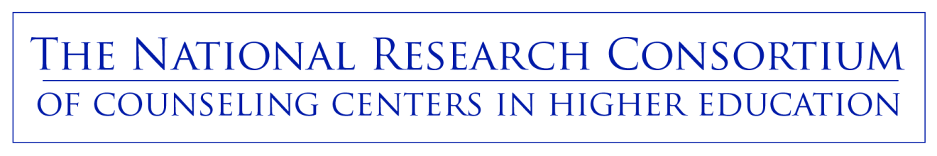
Email / Press Release from School

“__(name of school)__, in conjunction with the National Research Consortium of Counseling Centers in Higher Education, will launch a national study in the spring of 2011. Students will be randomly selected to participate in an online survey about students’ responses to stressful experiences. Students who participate in this study have the opportunity to contribute to their campus community by helping researchers understand the issues students face and how students can be better supported. Everyone who participates in the study will have the chance to enter a drawing to win an Amazon.com gift card.”

